**Monday**

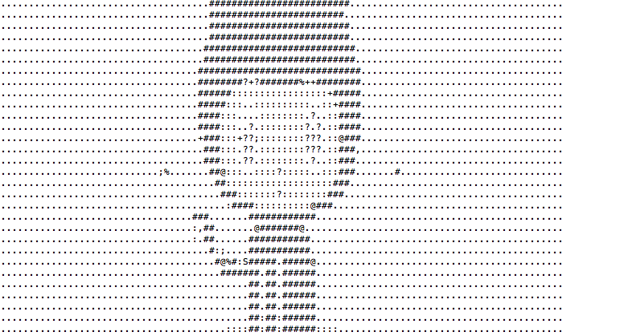

1. I used pip install delorean

Then from that I ran the commands that were given in Canvas and this is what printed out:

Delorean(datetime=datetime.datetime(2018, 9, 14, 16, 29, 42, 791822),

timezone='US/Eastern')

3. I used the command wget <http://www.colorado.edu>

4. I used the command grep Colorado index.html –c and it found 16 lines

5. I used the command grep Colorado index.html > search_results.html

(I worked with Jacob on problems 4 and 5)

**Wednesday**

Hypothetical data sets

1. They see how many people that sign up for the classes that the Rec offers to students.
2. They could pick a random set of 10 students and see how many times a week they swipe in to the Rec, then track these students GPA’s
3. They could see over the course of a school year when students visit the gym most, so they would track swipes, to see if the time of year people more frequently go to the gym, correlates with school schedules such as the times that midterms or finals come around.

CoNVO method for the CU Rec Project

Context:

**Stakeholders:** CU

**What are they trying to achieve?:** They are trying to determine the current use of the gym from students to try and see where they can improve so they understand the recent findings of the students that are active and use the gym can lead to them having a higher GPA.

**What work will the project advance?** The project help advance the Rec for students to be more interested in attending and being active as well as it can help advance the theory that if students are active it can lead to a higher GPA. So this can advance CU’s Rec as a center for students as well as if they improve the Rec and students are more interested in attending it can advance students health and GPA’s.

**Who is the target audience?** CU student body

Needs:

**What problems could be fixed using this data?** The current attendance problem, fixing the issue of why the students who are not coming to the gym, can be fixed by fixing certain aspects of the Rec. Also the issue of getting students who do not come to the gym, and who may have a lower GPA, getting them active and hopefully them being active can help improve their study habits.

**What is the specific utility of the results to the organization?** Improving the usage of their facility and their students GPA’s

**What will we know that we didn’t before?** How the gym is currently being used and what can be improved to help raise the attendance rates.

Vision:

**What techniques could we use to address our needs?** Gathering specific data

**How do our methods integrate our context?** In order for CU to understand what the current rate of attendance and usage of their facility is it is necessary we gather data such as how many students swipe in during the week, how many people actually attend the classes, etc. and with using data collection methods, we can integrate the context by understanding half of the theory or of those who go to the gym, can lead to them having a higher GPA. We are using methods to break down the theory and personalize it to CU to understand the students gym habits here at CU.

**What will be have when we are done?** We will have information that CU can use to improve certain aspects of their facility or marketing methods to then go on to the next half of the theory that if the students get more involved in the activities at the gym, then we can then find out if that leads to effects on GPA.

Outcome:

**How will our results be used?/How will new knowledge be integrated back into the organization?** The results will be used to then improve where they see issues such as attendance, figure out ways to make the gym more appealing or market classes or activities offered. Then once the changes are made it can then be looked at again to see the difference in students attending, and then try and see if if there is an increase, has students GPA’s also increased.

**What will happen when we are done?** Improvements can happen, then once improvements are made, we can then try and track again to see if there is a difference.

**Who handles the data next?** It would then be given back to whoever handles CU’s rec design or marketing so then they can make changes based on the data that was revealed.

**Friday**

**1st instance**

Austin Texas Bombings

What was the problem?

There had been multiple bombings around the area of Austin Texas, eventually there was a confession video, but that person never said any reason why they did it, there was no motive that was stated, so a motive was something the police wanted to figure out.

What data was available?

The locations of each of the bombings.

What methods were used?

Mapping out the locations to see like John Snow, where these events were happening to try and figure out why it was happening where it was.

What did they find?

They found that some bombings were in areas where mostly minorities lived, so the cops tried to conclude it was a racial issue.

If you were to tackle this same problem today, what would you do differently?

Nothing, I think what they did was all they could do with the data that was provided.

**2nd Instance**

Chipotle E Coli breakout

What was the problem?

There had been reports of people becoming infected with the outbreak strain of E coli that was linked to eating at Chipotle

What data was available?

The reports of the people getting infected, so numbers, as well as, location of those people to pin point where the problem is coming from.

What methods were used?

The testing of the produce being sent to these chipotles, the testing of those who were infected, and the tools that were within the restaurants

What did they find?

They shut down 43 restaurants as a result in the Washington Oregon area in response to outbreak. They could pin point what restaurants were infected, and track back to the supplier to see where the issue began. The FDA concluded traceback of multiple distributed ingredients, they found it can be common within the Mexican food business.

If you were to tackle this same problem today, what would you do differently?

I don’t think anything differently, I think they handled it how they should have.

**3nd Instance**

Romaine lettuce recall

What was the problem?

There was 35 reported cases of illness from consumption of infected romaine lettuce being sold in stores.

What data was available?

The reports of the illnesses, and the geographical data of where the reports are, where they bought their lettuce, and ultimately where did that store buy its lettuce from to trace back to the distributer.

What methods were used?

Testing and mapping out the road back to where the lettuce was originally grown

What did they find?

They found that the infected lettuce came from Arizona so they alerted everyone to make sure the lettuce they were buying did not come from Yuma Arizona.